SOFTWARE DESIGN DOCUMENT
Online Job Portal

Version 1.0



By
NAME
ROLL-NO

SUBMITTED BY
Ali Hassan (F24BINFT7M04024)
SUBMITTED TO
Ms.Kainat

Department of Information Technology
Faculty of Computing

The Islamia University of Bahawalpur

Contents
1 INTRODUCTION 1
2.1 Software Development Life Cycle 1
2.2 SDLC Model 2
2.2.1 Scrutinizing Our Project Model 3
2.2.2 Waterfall Model 3
2.2.3 Waterfall Model Design 3
3 SYSTEM OVERVIEW 5
3.1 Overall Description 5
3.2 Product Perspective 5
3.3 Software Interface/Programming Interfaces 6
3.4 Hardware Interface 6
3.5 Product Function 6
4 Identifying External Entities 7
4.1 Refined Entities 7
4.2 Summary of Requirements (Initial Requirements) 7
5 DESIGN MODELS 8
5.1 Class Diagram 8
5.2 Sequence Diagram 9
5.5 State-Transition Diagrams (STD) 12
5.6 Data Flow Diagram 13
5.61 Context DFD 13
6 DATA DESIGN 14
6.1 Data Description 14
6.2 Data Dictionary 14
7 ALGORITHM & IMPLEMENTATION 15
7.1 Component Diagrams 16
8 Human Interface Design 17
8.1 Interfaces 17
8.2 Software Interfaces 17
8.4 Communications Interfaces 17
9 SCREEN IMAGES 18
19
10 APPENDIXES 19

Revision History
Name | Date | Reason for changes | Version
 | 01/01/2026 | N/A | 1.0

Application Evaluation History
Comments (by committee)  *include the ones given at scope time both in doc and presentation | Action Taken

Supervised by

Signature

1 INTRODUCTION
In this project, we are required to develop a web-based application on an Online Job Portal. In this time where everyone is either experienced or fresher, is in search of a job. This job portal can prove to be very helpful since it allows users of different profiles to upload their CVs and search for jobs based on their qualifications. Every user can access through user id and apply for multiple jobs at a time. Currently, we are working on a manual system where data is stored in the form of registers. Viewing available jobs or applying for the job at the agency can be done for which job seekers has to go to the agency and check the available jobs at the agency.
Job seekers check the list of jobs available and apply for the job. Then the agency will show available jobs for the job seeker for his qualifications and then updates the jobs database. The developed Online Job Portal is web-based which Requires Employee Registration & Profiles, Job Search, Employer Registration & Profiles, and Subscription Option for both Employee and Employer etc. Employer can add Own Profile and post jobs, and Job Seeker can Search Jobs based on Geographical Area (Country, State, and City), Qualification, and Company wise or based on Experience and Expertise wise.

2 Design Methodology and Software Process Model

2.1 Software Development Life Cycle

The systems development life cycle (SDLC), also referred to as the application development life cycle, is a term used in systems engineering, information systems and software engineering to describe a process for planning, creating, testing, and deploying an information system. The systems development life-cycle concept applies to a range of hardware and software configurations, as a system can be composed of hardware only, software only, or a combination of both.

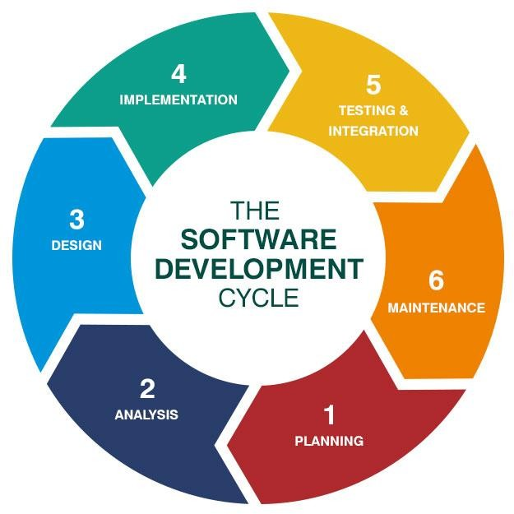

Figure 2.1

2.2 SDLC Model
The software development models are the various processes or methodologies that are being selected for the development of the project depending on the project’s aims and goals. Many development life cycle models have been developed to achieve different required objectives. The models specify the various stages of the process and the order in which they are carried out.
The selection of models has a very high impact on the testing that is carried out. It will define what, where and when of our planned testing, influence regression testing and largely determine which test techniques to use. There are various Software development models or methodologies. They are as follows:

      - Waterfall model
      - V model
      - Incremental model
      - RAD model
      - Agile model
      - Iterative model
      - Spiral model
      - Prototype model
Choosing the right model for developing the software product or application is very important. Based on the model the development and testing processes are carried out.

2.2.1 Scrutinizing Our Project Model
Selecting an accurate model for developing software invention or request is very significant. Founded on the model the expansion and testing processes are accepted out. As the Waterfall model is more traditional and easier to gather requirements and analyzing system, we choose the model according to complete the project. This technique works well for big projects that may take numerous to progress

2.2.2 Waterfall Model
The Waterfall Model was the first Process Model to be introduced. It is also referred to as a linear- sequential life cycle model. It is very simple to understand and use. In a waterfall model, each phase must be completed before the next phase can begin and there is no overlapping in the phases.
The Waterfall model is the earliest SDLC approach that was used for software development. The waterfall Model illustrates the software development process in a linear sequential flow; hence, it is also referred to as a linear-sequential life cycle model. This means that any phase in the development process begins only if the previous phase is complete. In waterfall, model phases do not overlap.

2.2.3 Waterfall Model Design
Waterfall approach was the first SDLC Model to be used widely in Software Engineering to ensure success of the project. In "The Waterfall" approach, the whole process of software development is divided into separate phases. In the Waterfall model, typically, the outcome of one phase acts as the input for the next phase sequentially.

Following is a diagrammatic representation of different phases of waterfall model.

Figure 2.2

The sequential phases in Waterfall model are:
      - Requirement Gathering and analysis: All possible requirements of the system to be developed are captured in this phase and documented in a requirement specification doc.
      - System Design: The requirement specifications from the first phase are studied in this phase and system design is prepared. System Design helps in specifying hardware and system requirements and helps in defining overall system architecture.
      - Implementation: With inputs from system design, the system is first developed in small programs called units, which are integrated in the next phase. Each unit is developed and tested for its functionality which is referred to as Unit Testing.
      - Integration and Testing: All the units developed in the implementation phase are integrated into a system after testing of each unit. Post integration, the entire system is tested for any faults and failures.
      - Deployment of system: Once the functional and non-functional testing is done, the product is deployed in the customer environment or released into the market.
      - Maintenance: There are some issues which come up in the client environment. To fix those issues patches are released. Also, to enhance the product some better versions have been released. Maintenance is done to deliver these changes in the customer environment.
All these phases are cascaded to each other in which progress is seen as flowing steadily downwards (like a waterfall) through the phases. The next phase is started only after the defined set of goals are achieved for previous phase and it is signed off, so the name "Waterfall Model". In this model phases do not overlap

3 SYSTEM OVERVIEW

3.1 Overall Description
An online job portal system package is one that agencies can use to improve their business performance. The development of online job portal systems has many benefits for its members. This system provides vacancy index and information to the members and helps them in choosing the vacancies. The administrator can keep the list of vacancies constantly updated, so that the members (job seekers and employment agencies) always have the latest information. Explained in detail with extremely difficult experienced work. The resume includes information about your experience, project and volunteer work. All details of your work history and volunteer experience should be clear and concise, but descriptive. After reading your description, the employee decides on the job seeker. The employee tests all the necessary experience and skills. More about this source text Source text required for additional translation information send feedback Side panels.

3.2 Product Perspective
A design site where job design professionals want to solve the problem. All job seekers search for jobs on the interface with various functions. Space holders find places in the same homepage app which contains all the details. The main goal of career guidance is to provide all job instructions with different experience and skills.
- Find the suitable jobs
- Search all job at one place of home page
- How to create an account on any registration field
- Sign in with your personal id that is linked with job portal
- All the description is available in every job link that talk about the requirement.

3.3 Software Interface/Programming Interfaces
Programming interfaces are the dialects, codes and messages that projects use to speak with one another and to the equipment.
Models are the following is described Windows.
    - Mac
    - Linux
    - Working frameworks
    - SMTP email
    - IP organize conventions
The product drivers that enact the fringe gadgets.

3.4 Hardware Interface
There is a different type that is interacting with hardware.
    - Command line (CL)
    - Graphical user interface (GUI)
    - Menu driven (MD)
    - Form based (FB)
    - Natural language (NL)

3.5 Product Function
There are some functions that are described about the function of job counseling.
    - Search your jobs
    - Connected jobs seeker with the employer
    - All instructions are posted on the web page that is about the jobs.
    - We can easily apply for any suitable post on one platform.
    - The entire user connective at single web application that is advertising different jobs.
    - The interview letter is sent to your email address after reading your CV.
    - If you have skills and are a responsible person, hardworking then you are selected

4 Identifying External Entities
The identification of the external entities is based on the information contained in the above abstract. The Identification of External entities is done in two phases
Over Specify Entities from Abstract
      - Admin side
      - Employee side
      - User side

4.1 Refined Entities
After refining the entities, we found the following entities to fit our Business Logic.
      - Admin side
      - Employee side
      - User side

4.2 Summary of Requirements (Initial Requirements)
Our purposed system must fulfill the requirements as follow
- Add New Jobs
- View / Block Jobs
- Select Suitable Candidates for the Jobs
- Apply For Jobs
- View Status
- View / Del Job Seekers / Employee

5 DESIGN MODELS

The applicable models may include:
- Class Diagram
- Sequence Diagram
- State Transition Diagram
- Data Flow Diagram

5.1 Class Diagram

Class diagrams are used to represent the relationship between different classes. In UML class diagram is represented by a rectangular box having three sections. At the top section we write the class name, in second section we write the attributes of the class, and the last section contains the operations/methods of the class.
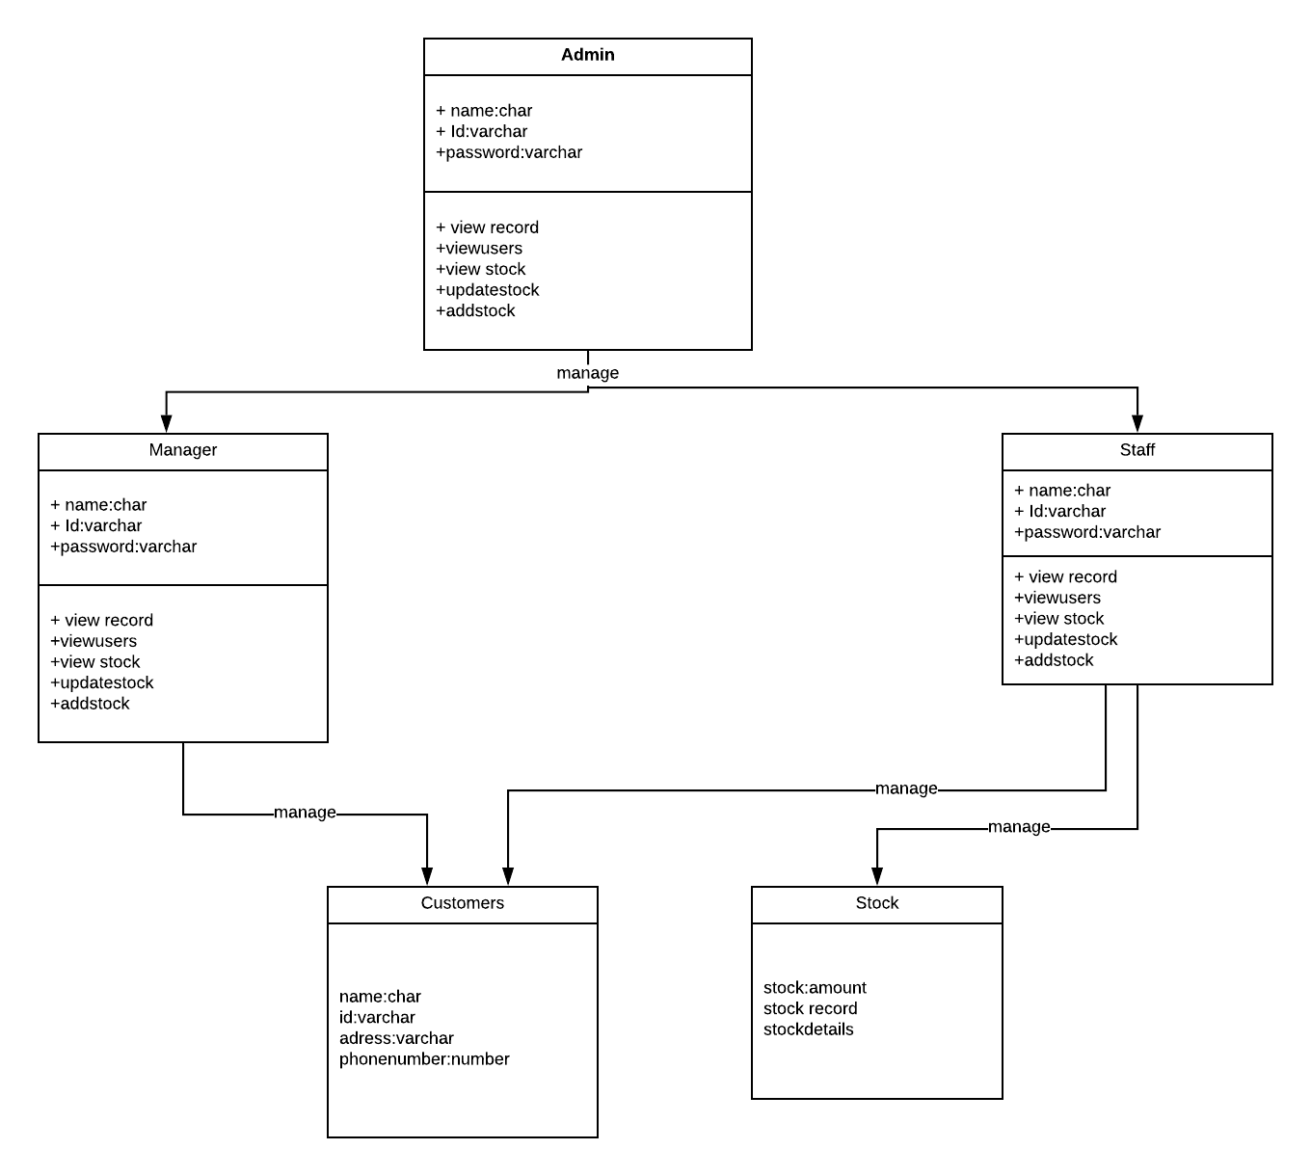

Figure 5.1

5.2 Sequence Diagram

A sequence diagram is used to show the sequence of events. It is used to show the sequence of the functions in our system with respect to time. In sequence diagram the events are arranged on x axis and the time spot is arranged on y axis. Sequence diagram is used to show the dynamic behavior of our system. In sequence diagram the forward message is represented by a solid line and the reply message is represented by a dotted line. The lifeline of any object in the system shows the time interval for which an object is active. The lifeline of an object is shown by a vertical dotted line. The interval for which an object is activated/functional its lifeline is shown by a rectangular bar overlapping the solid line. In our system there are three sequence diagrams used to explain the dynamic behavior of the system. A sequence diagram shows how a user interacts with this web application in a sequential way. The user, either a Job Provider, manager or Job Seeker interacts with our system in the form of messages.
Figure 5.2 Add User

Figure 5.3 Update User

Figure 5.4 Delete User

5.5 State-Transition Diagrams (STD)
A state machine is any device that stores the status of an object at a given time and can change status or cause other actions based on the input it receives. States refer to the different combinations of information that an object can hold, not how the object behaves. To understand the different states of an object, you might want to visualize all of the possible states and show how an object gets to each state, and you can do so with a UML state diagram.
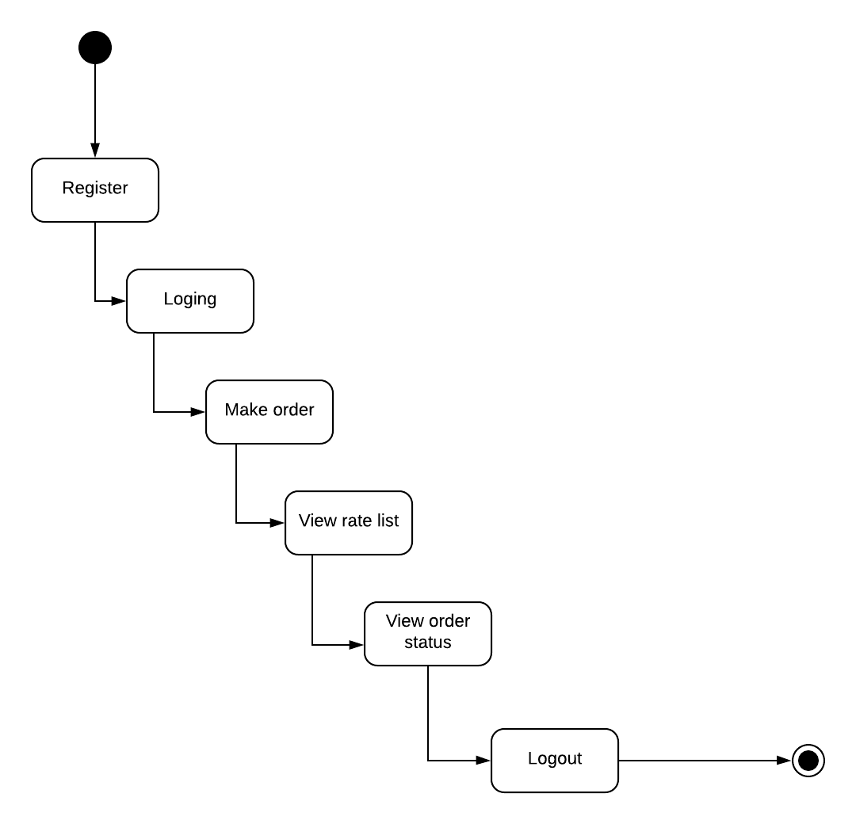
Each state diagram typically begins with a dark circle that indicates the initial state and ends with a bordered circle that denotes the final state. However, despite having clear start and end points, state diagrams are not necessarily the best tool for capturing an overall progression of events. Rather, they illustrate specific kinds of behavior—in particular, shifts from one state to another.
Select Jobs
View Company

View Jobs

Figure 5.5 STD

5.6 Data Flow Diagram
A data flow diagram shows the way information flows through a process or system. It includes data inputs and outputs, data stores, and the various sub processes the data moves through. DFDs are built using standardized symbols and notation to describe various entities and their relationships. Data flow diagrams visually represent systems and processes that would be hard to describe in a chunk of text. You can use these diagrams to map out an existing system and make it better or to plan out a new system for implementation. Visualizing each element makes it easy to identify inefficiencies and produce the best possible system.
Data flow diagrams are also categorized by level. Starting with the most basic, level 0, DFDs get increasingly complex as the level increases. As you build your own data flow diagram, you will need to decide which level your diagram will be.

5.61 Context DFD
Level 0 DFDs, also known as context diagrams, are the most basic data flow diagrams. They provide a broad view that is easily digestible but offers little detail. Level 0 data flow diagrams show a single process node and its connections to external entities.
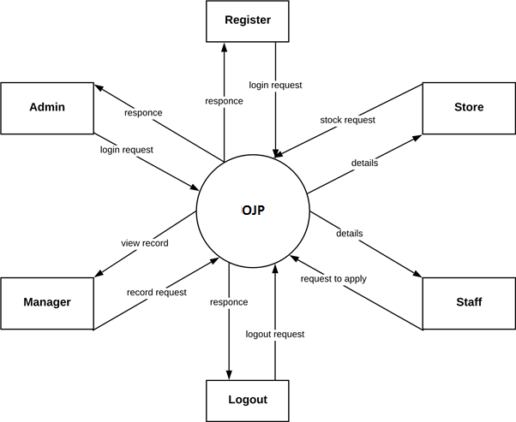
Level 1 DFD is still a general overview, but they go into more detail than a context diagram. In a level 1 data flow diagram, the single process node from the context diagram is broken down into sub processes. As these processes are added, the diagram will need additional data flows and data stores to link them together.
Users

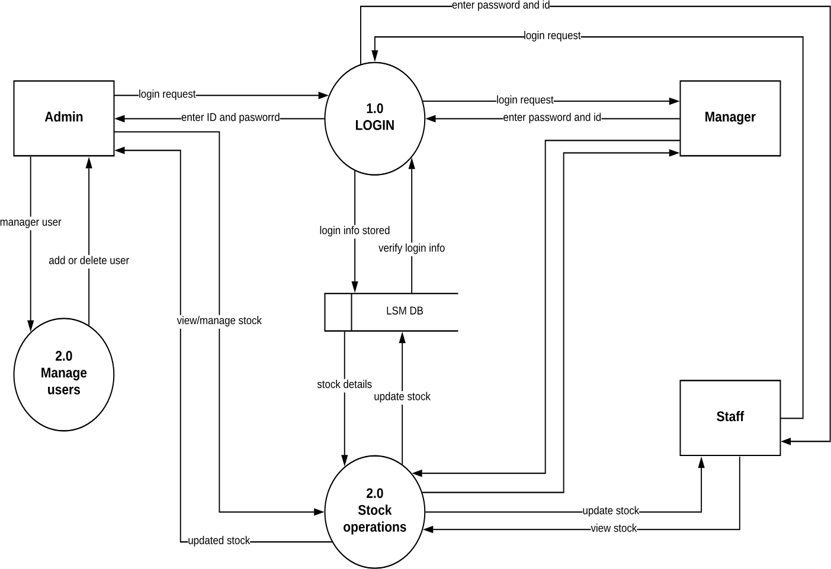

Figure 5.7 Detailed DFD

6 DATA DESIGN

6.1 Data Description
We use MYSQL database with PHP as a backend Language and HTML5 for Front End Language.

6.2 Data Dictionary
After carefully understanding the requirements of the client the entire data storage requirements are divided into tables. The below tables are normalized to avoid any anomalies during data entry.

Table 6.1
Field Name | Data Type | Constraints | Description
Master ID | Numeric | Primary key | User ID
Username | Var Char | Unique Key | Username
Password | Var Char | Unique Key | Password

7 ALGORITHM & IMPLEMENTATION

Table 7.1

ID | User Requirements | Forward Traceability
U1 | Registered and Guest User Allowed | S1, S3, S4
U2 | User Find Jobs | S5
U3 | User Login as Guest | S1, S3, S4
U4 | Jobs Detail for Registered User | S1, S3, S5
U5 | Registered User search Jobs | S1, S3, S6
U6 | Register User Set Wish list | S1, S3, S7

Table 7.2

ID | System Functional Requirements | Forward Traceability
S1 | Login / Registered Page Should be Display | U1
S2 | User is accepted by the System when all the relative  information corrects | U1
S3 | Data store by the System | U1
S4 | Guest user allowed to find the jobs in a System | U2
S5 | jobs Should be allowed to place in a System | U2
S6 | Jobs shown by the user in a system | U3
S7 | Jobs cauterized by the User in a System | U3
S8 | Registered User set wish list through the System | U3

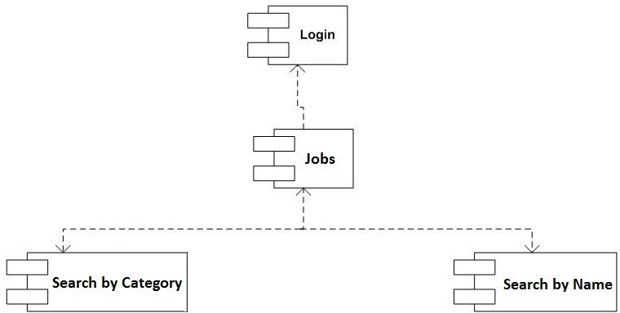
7.1 Component Diagrams

Figure 7.1 Component diagram for find Jobs

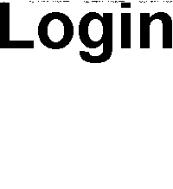
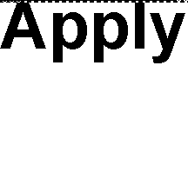

Figure 7.2 Component diagram for Apply Only

8 Human Interface Design
System Interfaces
Our system has three types of interfaces
- Admin side
- Employee side
- User side

8.1 Interfaces
Our application has two interfaces
- User Side
- Admin Side

8.2 Software Interfaces
- PHP language
- web server
- windows 7,8

8.4 Communications Interfaces
MYSQL is our communication interface

9 SCREEN IMAGES
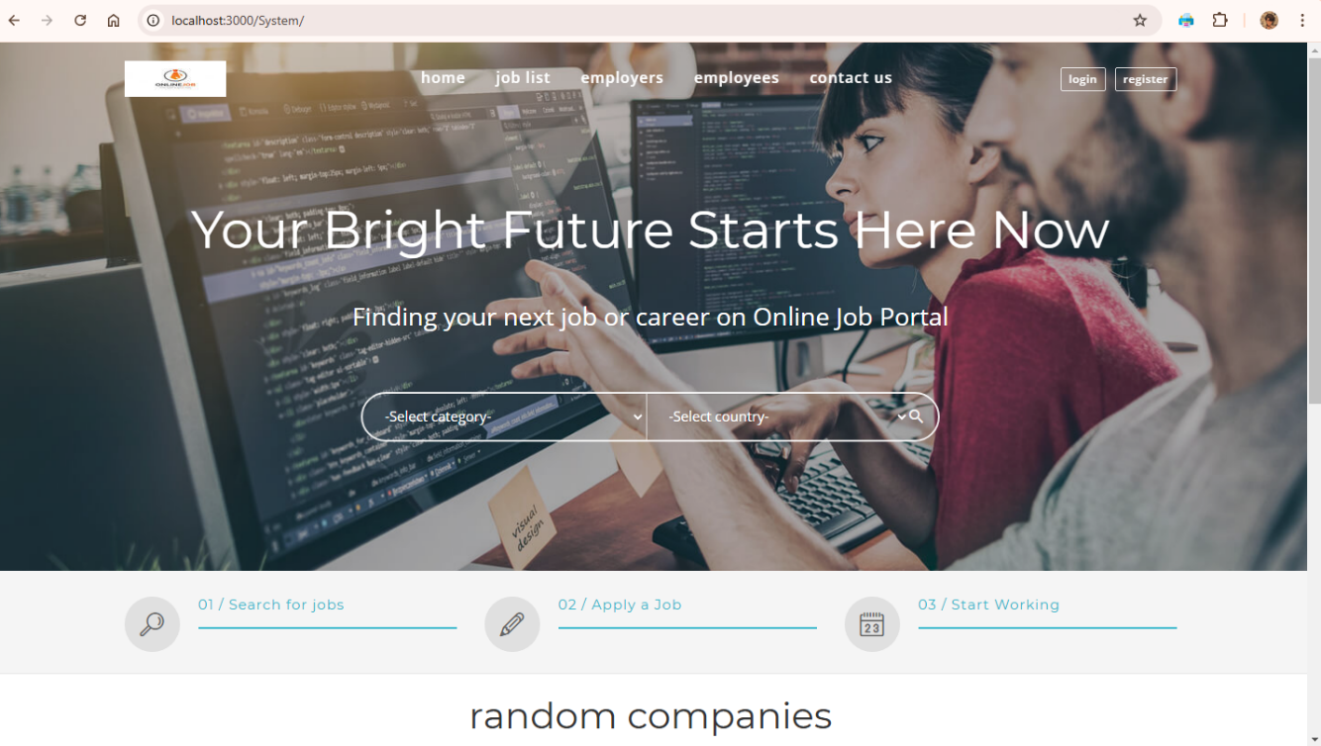
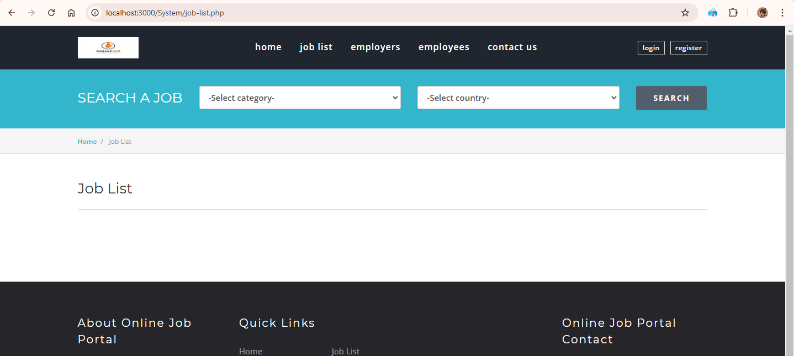

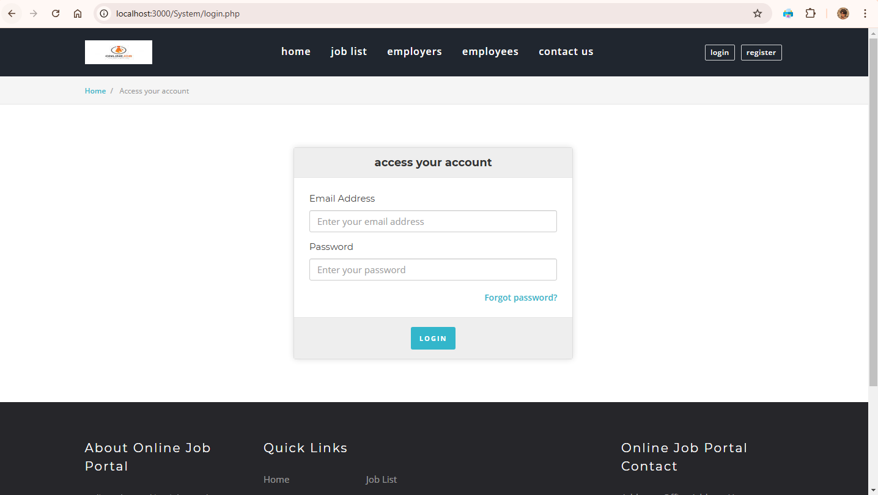
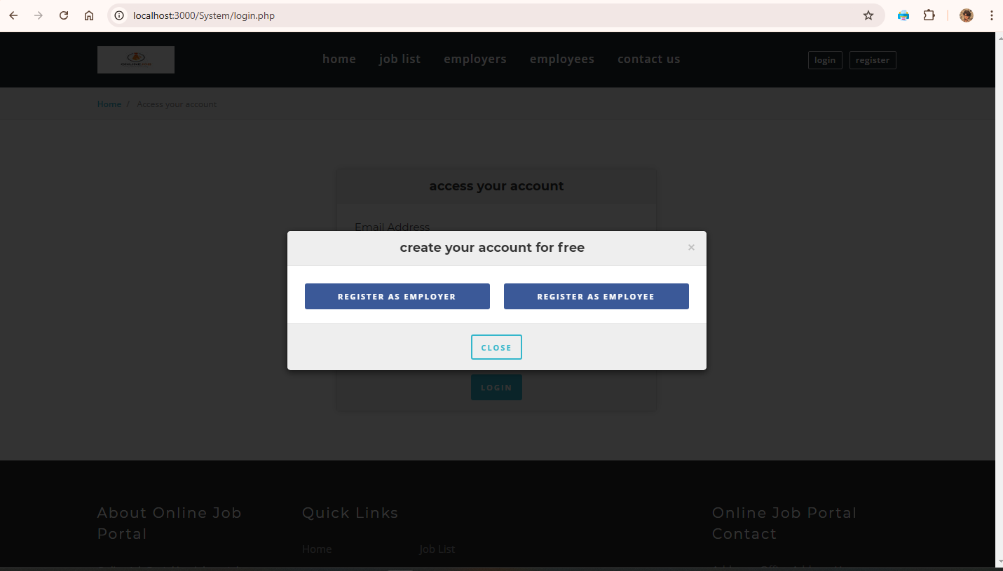

10 APPENDIXES
My Project is a web-based application that can run on any browser with internet functionality. You don't need to install any hardware or software tools. On this platform you have easy access to the vacancy and candidate. It is easy for all users.

